Brentwood Transportation Chapter

introduction
Transportation planning is critical for maintaining the vitality of Brentwood. Ensuring a safe and efficient transportation network requires long-range transportation planning as part of the Town’s Capital Improvement Program and Master Plan. Road improvements and maintenance are a considerable expense to the town that must be reviewed on a regular basis.
Brentwood’s Transportation chapter provides an overview of existing conditions of the road network, traffic flows and patterns, public safety, and non-motor vehicle networks. This chapter also identifies key challenges and issues facing Brentwood’s transportation network and provides goals and recommendations for prioritizing transportation infrastructure investment overtime.
The challenges and issues facing Brentwood’s transportation network identified in this chapter were brought to light by community input in the 2022 Master Plan Community Survey conducted as part of this Master Plan Update, and by data analysis conducted by the Rockingham Planning Commission. Challenges include dangerous intersections along Route 125, traffic speed on state and local roads, and bike and pedestrian safety on heavily utilized roadways, including Middle Road and North Road.
By providing a baseline of existing conditions, including dangerous intersections and high crash locations, in combination with vehicle, pedestrian, and bike usage counts, Brentwood can begin to understand where improvements should be made and how to prioritize transportation infrastructure projects as they relate to capacity and safety of the community’s transportation network.

existing conditions

Road network
New Hampshire state law organizes the highway system into seven classes: Class I, II, III, III-a, IV, V, and VI. Class I and II are state highways that are controlled and maintained by NH Department of Transportation (NHDOT), whereas Class IV, V, and VI highways are local roads controlled and maintained by the municipality. Class III roads are state recreational roads, which are maintained by NHDOT.

Roads
Brentwood is served by four state highways, NH Route 101 (Class I), NH Route 125 (Class II), Middle Road/Route 111A (class II) and Route 107 (Class I). The majority of town is served by Class V, Town Roads and Streets, along with a handful of private roads. Private roads are not maintained by the state or municipality.
Brentwood has approximately 66 miles of roadway including state highways, roads, and local roads. Map 1. Road Classification shows Brentwood’s transportation network by road classification.
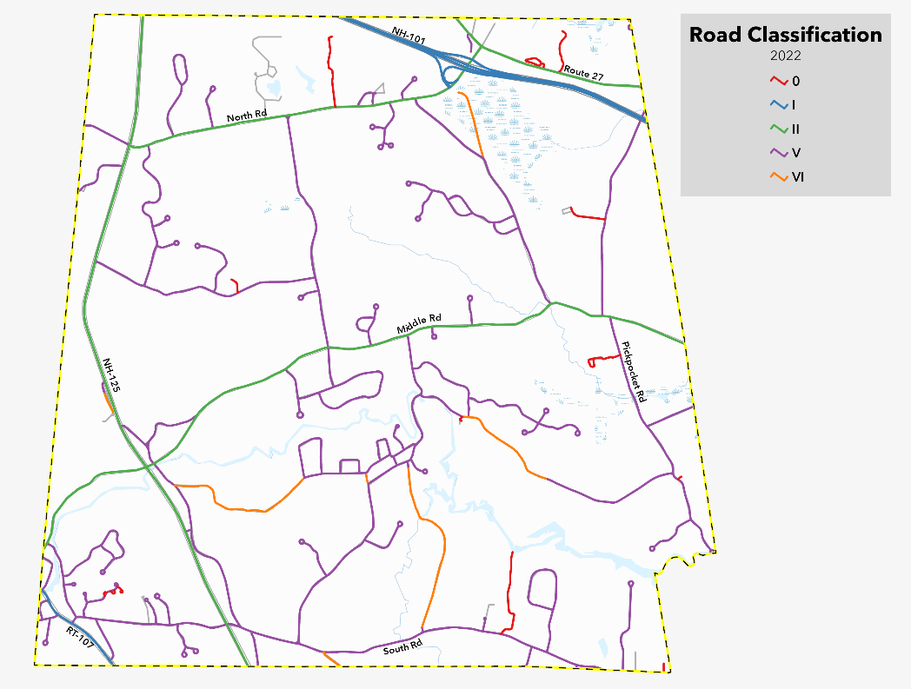
Table 1. Road Classification BY Mileage
State Class | Total Road Mileage | Percent of Total Road Mileage
Class 0 Private Roads | 2.75 | 4.1%
Class I Primary State Highway | 6.9 | 10.3%
Class II Secondary State Highway | 13.3 | 20.0%
Class V Town Roads and Streets | 40.0 | 60.1%
Class VI Unpaved | 3.8 | 5.7%
The major corridors and connectors serving Brentwood include:

- Route 101
- Route 125
- Route 111A/Middle Road
- North Road
- Route 27
- Route 107

Road Conditions & Management
Municipal-owned and maintained roads in Brentwood are maintained by the Brentwood Highway Department. In general, roadway management recommendations are to rebuild a road every twenty years based on deterioration from use and weather overtime. In addition to planning maintenance, the Brentwood Road Agent is responsible for estimating road bond prices, carrying out all inspections of new road construction, and issuing driveway permits.
Map 2. Surface Type shows paved and unpaved roads in Brentwood. Brentwood includes about 60 miles of paved roads, representing 90.8% of total road miles in town.
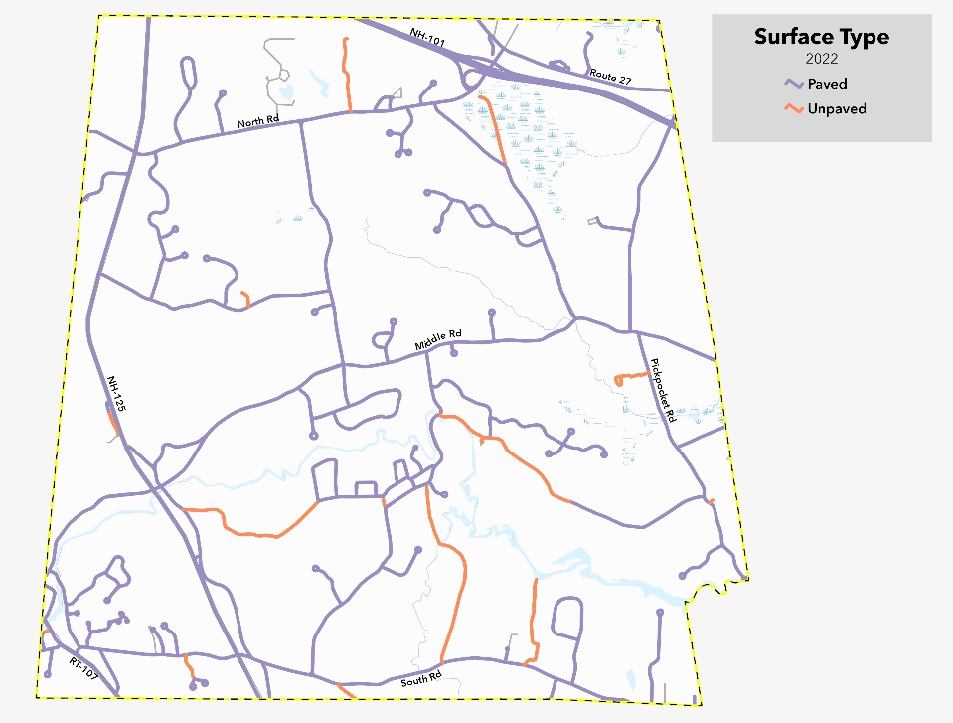

Bridges

The state of New Hampshire compiles a list of bridges, on an annual basis, that are either state-owned and maintained or municipal-owned and maintained. The bridges are then classified as not deficient or deficient (aka Red Listed).
Red list bridges are inspected on an annual basis due to poor condition or being structurally deficient. There is one red listed, municipal-owned bridge in Brentwood on Mill Road crossing over the Exeter River. Brentwood does not have any state-owned red list bridges.
Table 2 and Table 3 below detail how the 14 bridges in Brentwood are distributed.

Table 2. 2021 NHDOT Not Deficient Bridge Summary - Brentwood:
Bridge Number | Owner | Facility Carrier | Feature Crossed | Est. ADT (year) | Condition | Year Modified/Built
057/049 | NHDOT | NH107 | Exeter River | 4394-20 | Not Deficient | 1988
071/064 | NHDOT | NH125 | Exeter River | 10582-20 | Not Deficient | 1960
073/065 | Municipality | Crawley Falls Rd | Exeter River | 534-20 | Not Deficient | 2014
103/042 | Municipality | South Road | Little River | 168-20 | Not Deficient | 1967, 2009
107/075 | Municipality | Haigh Road | Exeter River | 521-20 | Not Deficient | 1979
116/120 | NHDOT | North Road | NH101 | 3100-20 | Not Deficient | 1992
123/086 | NHDOT | NH111A | Dudley Brook | 1556-20 | Not Deficient | 1936
136/072 | Municipality | Pickpocket Rd | Dudley Brook | 827-20 | Not Deficient | 1960
136/109 | NHDOT | NH101 EB | Little River | 20566-20 | Not Deficient | 1997
137/108 | NHDOT | NH101 EB | Pine Road | 20566-20 | Not Deficient | 1997
137/109 | NHDOT | NH101 WB | Little River | 20604-20 | Not Deficient | 1997
138/108 | NHDOT | NH101 WB | Pine Road | 20604-20 | Not Deficient | 1997
138/110 | NHDOT | Pine Road | Little River | 168-20 | Not Deficient | 1998
Updated March 2022.

Table 3. 2021 Municipal Bridge Red List - Brentwood:
Bridge Number | Facility Carrier | Feature Crossed | Est. ADT (year) | Date of Most Recent Inspection | Bridge Posting | Year Modified/Built
060/054 | Mill Road | Exeter River | 388-20 | 11/24/2021 | E-2 | 1967
Updated March 2022.

Traffic flow & Travel Patterns

Traffic Count Data
The New Hampshire Department of Transportation (NHDOT) and the Rockingham Planning Commission (RPC) conduct annual traffic counts through the state and region.
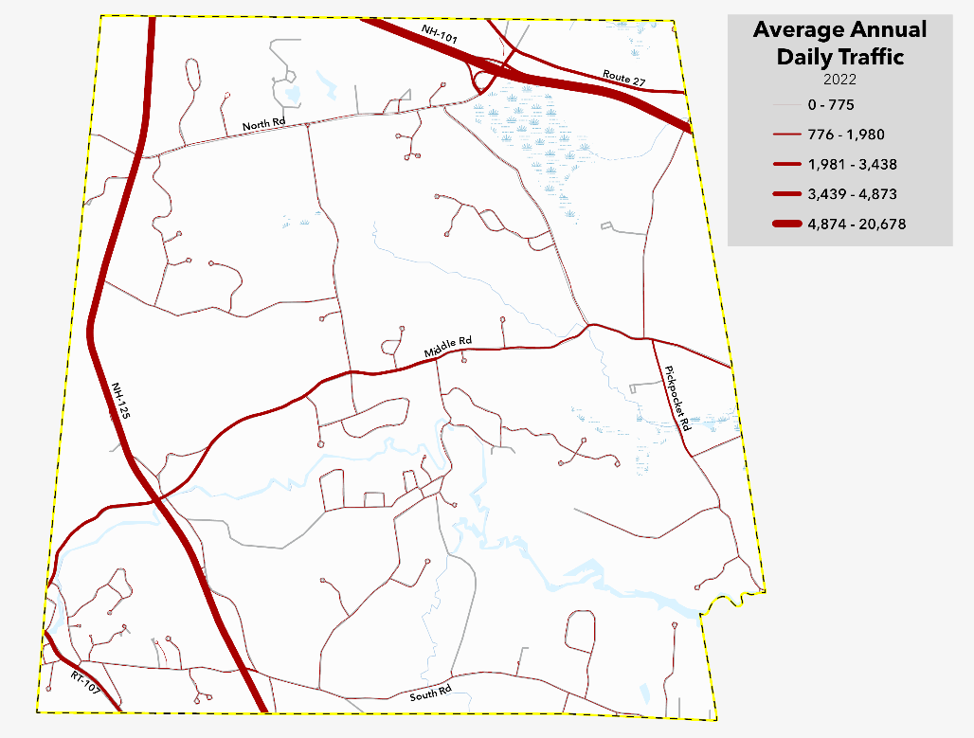
Average Annual Daily Traffic (AADT) is the total volume of traffic at a given location for a 24-hour period that represents an average day for the year. Map 3. Average Annual Daily Traffic shows Average Annual Daily Traffic in Brentwood in 2021. The most heavily trafficked roadways in Brentwood include NH Route 101, NH Route 125, NH Route 107, and Middle Road. Table 4 shows the AADT counts for major roads in Brentwood in 2018 compared to 2021.
Table 4. average Annual daily traffic – 2018 and 2021
Road | 2018 | 2021
NH Route 101 | 52,423 | 45,944
NH Route 125 | 15,370 | 11,551
NH Route 107 | 4,485 | 4,300
Middle Road | 2,205 | 1,922

Commuting Patterns
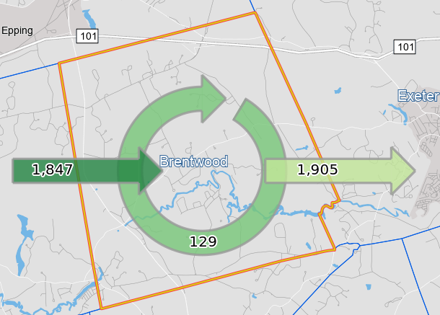
According to On The Map(a US Census tool that analyzes commuting patterns) in 2019 approximately 1,976 individuals were employed in the area. Of the 1,976 employed in the area, 1,847 (93.5%) lived outside of the town of Brentwood and 129 (6.5%) lived in the town of Brentwood. Of 2,034 living in Brentwood, 1,905 (93.7%) were employed outside of Brentwood and 129 (6.3%) were employed in Brentwood.

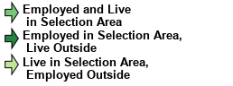

Note: Overlay arrows do not indicate directionality of worker flow between home and employment locations.

Public Safety

Crash Data
Crash or motor vehicle accident data is compiled annually by the NH Division of Motor Vehicles and local police reports. Crash data can be retrieved from the Fatality Analysis Reporting System (FARS), and is summarized in Table 5.
Between 2010 and 2020 there were a total of 556 motor vehicle crashes in Brentwood.
Table 5. Crash Type – 2010 to 2020
Crash Type | # of Crashes (2010 – 2020)
Other Motor Vehicle | 293
Bicyclist | 2
Animal | 26
Fixed Object | 123
Other | 35
Unknown | 77
Fatalities | 7
There were seven (7) fatal crashes that occurred in Brentwood between 2010 and 2020.

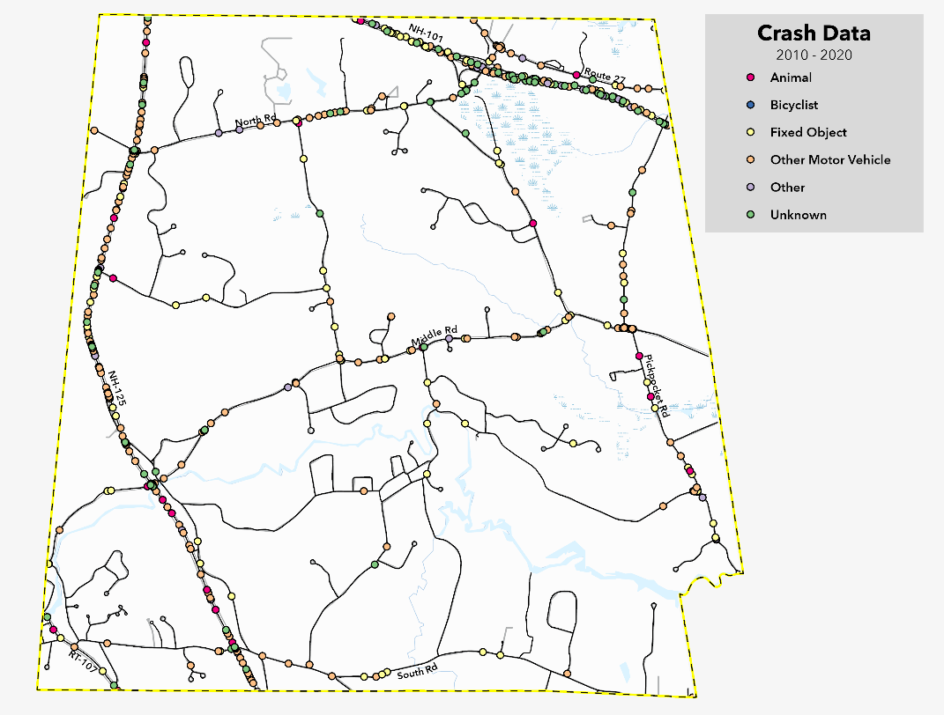
The fatal crashes occurred at the following locations: NH-125, Route 27 and Middle Road. Map 4. Crash Data shows the locations and type of all crashes in Brentwood between 2010 and 2020. The most recent fatal crash in Brentwood occurred in August 2022 at the intersection of Route 125 and South Road.

Intersections
Dangerous intersections in Brentwood have been determined using a hot spot analysis that identifies statistically significant spatial clusters of high values (i.e. hot spots) and low values (i.e. cold spots).

Intersections that have been identified as dangerous in Brentwood based on the hot spot analysis:
- Intersection of Middle Road & Route 125
- Intersection of South Road & Route 125
- Intersection of Pine Road and Middle Road (111A)
Also identified as dangerous or hazardous via community input in the Master Plan Survey (2022):
- Intersection of South Road & Route 125
- Intersection of Pine Road & Middle Rd (111A)
- Speed on Route 125
- Speed on Pickpocket Road

Bike & Pedestrian Networks

Brentwood has minimal pedestrian and bicycle specific corridors on their roadways such as sidewalks or bike lanes. The Town has multiple off-road recreational trail networks that are utilized by pedestrians and shown on Map 5. Pedestrian Usage which includes level of pedestrian usage based on data provided by Strava.
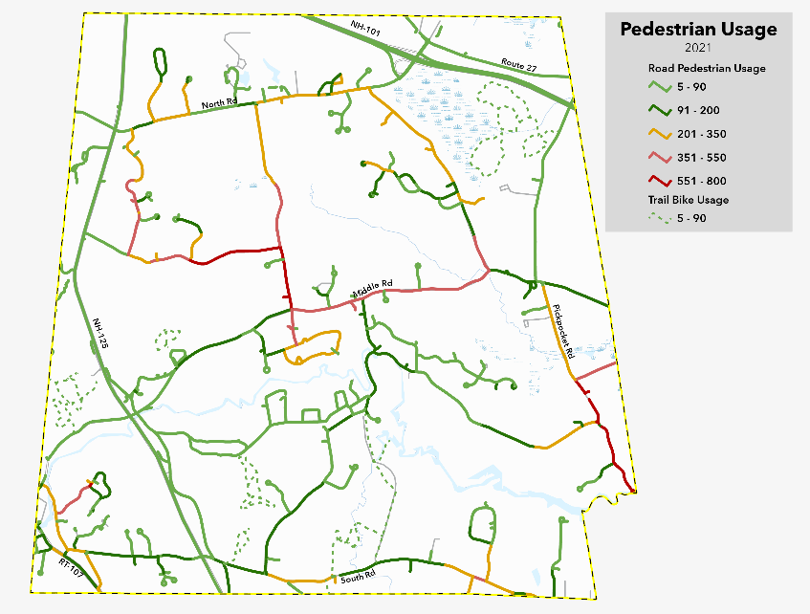

Various roadways in town are utilized for higher volume road biking, as shown on Map 6. Bike Usage which is also including data provided by Strava.
Route 107, North Road, and Route 27 are all roadways where the shoulder widths are four (4) feet or greater and have high bike usage of 601 rides per year or higher. These identified roadways may be good candidates for dedicated bike lanes.
Both Middle Road and Pickpocket Road are also identified as high bike usage but do not have the additional shoulder width available to add bike lanes.

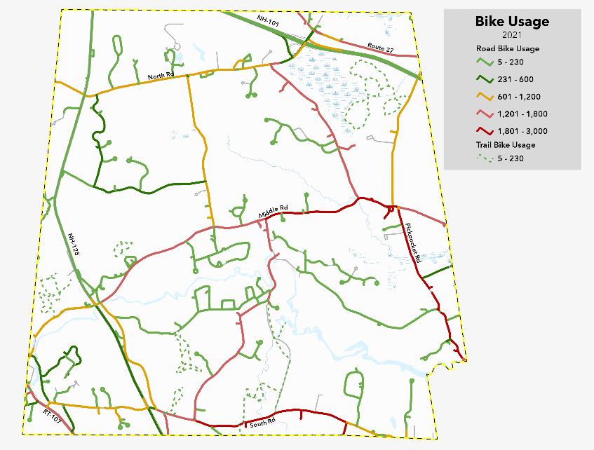

Level of Stress
New Hampshire Department of Transportation (NHDOT) determines Bicycle Level of Traffic Stress (LTS) by considering traffic speed, average daily traffic volume, presence of bike lanes and parking lanes, and conflict factors such as commercial/industrial zoning, bus lanes, or school zones.
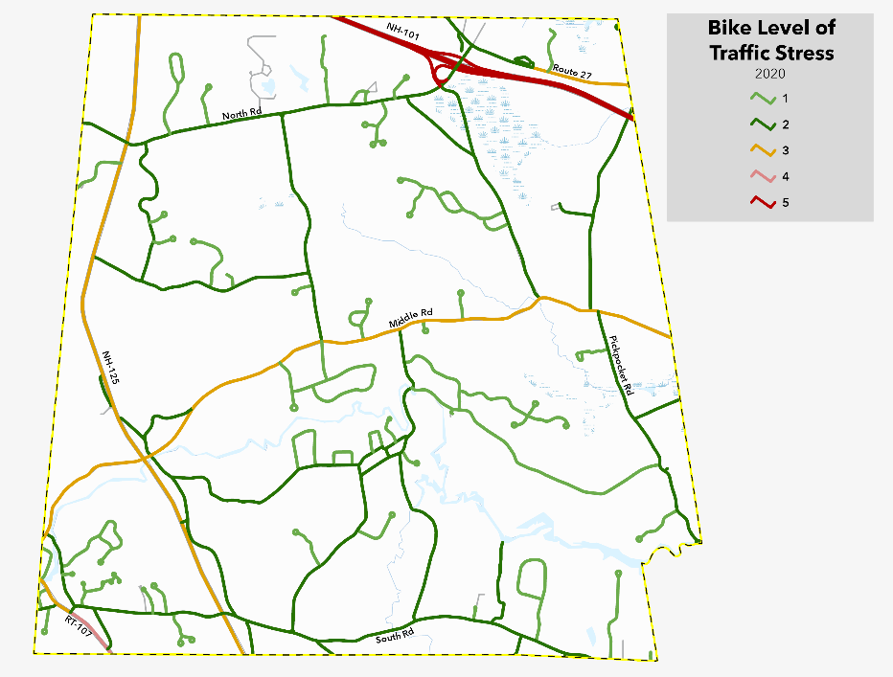
LTS is utilized to explain how comfortable a roadway feels to a person riding a bicycle on a scale of 1 to 4, 1 being the least stressful and 4 being the most. This measure can help us understand the overall comfort of a roadway for bicycle riders.

Map 7. Bike Level of Traffic Stress shows the bike LTS of the Brentwood transportation network, with majority of the local roads scoring a level 1 or 2, with state roads and Middle Road scoring a 3.

Regional Transportation

TASC
Transportation Assistance for Seacoast Citizens (TASC) is a community service organization that coordinates a group of volunteer drivers to transport persons who are unable to drive themselves. TASC services Brentwood, East Kingston, Exeter, Greenland, Hampton, Hampton Falls, Kensington, North Hampton, Rye, Seabrook, and Stratham. TASC provides rides to people 55 years or older and adults living with a medical disability that prevents you from driving.

Transportation & Land Use
Transportation and land use are linked in many ways and should be reviewed and planned for side-by-side. Transportation infrastructure can impact the types and location of new development in a community, inversely, new development can overwhelm or burden a transportation network if capacity and maintenance are not taken into consideration during the development review process. Expansion of or modifications of transportation infrastructure to accommodate new land uses may include the extension or expansion of roads and utilities, adjusting for traffic congestion, planning for emergency access, loss of open space, or increased air pollution when additional vehicle trips are required to access goods and services. Transportation planning requires consideration of these associated costs or impacts when developing land use regulations and during the development review process.

Impact fees
Brentwood’s Zoning Ordinance includes the provision for imposing impact fees on new development to compensate the Town and School District for the proportional share of capital facilities generated by a new development. Impact fees may be imposed to meet the needs occasioned by a development for the construction or improvement of capital facilities owned or operated by the municipality, including public road systems and rights-of-way, among others.

Bonding of roads
Roads will not be accepted by the Town of Brentwood for at least three (3) years after construction of the asphalt binder course is completed. A Maintenance Bond in the amount of 10% of the Construction Bond value will be required to be posted prior to releasing the Construction Bond. The Maintenance Bond must remain in effect until the road is accepted by the Town. Repairs to roads prior to acceptance will be accomplished by person or persons offering road for acceptance by the Town.
Roadways shall be constructed in accordance with the typical roadway section included as part of Brentwood’s subdivision regulation specifications. All work and materials shall be in accordance with the latest provisions of the NHDOT, Standard Specifications for Road and Bridge Construction, unless otherwise stated within the subdivision regulations.

Subdivision and site plan road requirements
Brentwood’s Subdivision Regulations include road requirements for design and construction of roadways in town. These regulations include details such as the arrangement of streets to provide for continuous connections between developments, roadway width, road grade maximums and minimums, frontage requirements, and erosion control measures, among other requirements. All storm drainage systems for roadways must be designed using NHDOT criteria for a twenty-five (25) year storm frequency.
All commercial, industrial or residential development proposed to be located on or having an effect on a town-maintained (Class V) road or street and any state highway shall be reviewed by the Planning Board and are required to provide a Traffic Impact Analysis that addresses impacts such as traffic circulation and access, pedestrian safety and access, off-street parking and loading, emergency vehicle access, and necessary off-site improvements.

Key issues & Challenges
Safety Challenges:
Roadways or intersections identified by the community as having safety challenges or concerns: | Major Concern:
South Road and Route 125 | Intersection
Pine Road and Route 125 | Intersection
Route 125 and South Road, Recreation Center, Route 27, Pine Road | Turning
Route 125 | Speed
Pickpocket Road | Speed
Residential Roads | General Safety (Speed)
Middle Road (Route 111A) | Bike & Ped Safety
North Road | Bike & Ped Safety
Additional consideration for sidewalks and crosswalks may be necessary in certain critical locations in town that have been identified as concern such as near the school, library, recreation center, Prescott to Lindy’s, and new developments.
Lighting & Noise:
Lighting along roadways has been identified as a concern for both drivers and to maintain the dark sky of Brentwood. Road noise and truck traffic, particularly along Route 125 have also been identified as a concern among community members.

Goals & Actions

Transportation Goal #1 Maintain and expand transportation network to encourage and support desired land use patterns in brentwood.
Action Items: |  | Responsible Party: | Timeframe:
T 1.1 | On an annual basis, identify capital projects to be included the Town’s Capital Improvement Program that maintain and support the existing transportation network, expand the transportation network to support land use, and enhance opportunities for safety improvements. | Selectboard, Budget Committee, Planning Board, Department Heads | Ongoing, Annual
T 1.2 | Identify and explore existing and potential sources of federal, state, and private funding for transportation projects. | Selectboard, Planning Board | Ongoing, Annual
T 1.3 | Review Brentwood’s land use regulations and development amendments as needed to ensure criteria for development on Route 125 includes an assessment of lighting and traffic impact along the corridor. | Planning Board | 2025
T 1.4 | Brentwood should continue to actively participate in the Regional MPO transportation planning process which includes the submission of a prioritized list of identified transportation improvements that may be eligible for federal funding. | Planning Board, Selectboard, with assistance from the Regional Planning Commission | Ongoing
T 1.5 | Review and prioritize road maintenance needs on an annual basis. | Selectboard, Highway Department | Ongoing, Annual

Transportation Goal #2 Strengthen the relationship between transportation planning and land use planning to encourage community connections in brentwood.
Action Items: |  | Responsible Party: | Timeframe:
T 2.1 | When updating Brentwood’s land use regulations, consider integrating mixed-use development particularly around the Route 125 and Middle Road, to encourage the integration of daily and civic activities. This may also serve as a community connection point between the east and west sides of Route 125 and begin to create a walkable, pedestrian scale ‘town center’. | Planning Board | 2025
T 2.2 | Better educate residents on available options for public transportation or ride share (such as TASC) for seniors and disable adults who may be unable to drive. | Selectboard, Planning Board | 2025

Transportation Goal #3 Achieve and maintain a safe transportation network that supports the rural character of the community.

Action Items: |  | Responsible Party: | Timeframe:
T 3.1 | Explore and identify traffic calming strategies along roadways and intersections that have been identified as problematic or unsafe including Route 125. | Planning Board & Selectboard with assistance from Regional Planning Commission | 2025
T 3.2 | Consider adopting a Complete Streets Policy for certain areas of town to ensure roadways are designed to accommodate all modes of transportation. Complete Streets is an approach to planning, designing, building, operating, and maintaining streets that enable safe access for all people including pedestrians, bicyclists, motorists and transit riders of all ages and abilities. | Planning Board | 2026
T 3.3 | Identify opportunities for widened shoulders, bike lanes, or sidewalks and options for pedestrian and bicycle connections and pathways. | Selectboard, Planning Board | 2026
T 3.4 | Identify and publicize public recreational trail networks. | Recreation Department, Trails Committee | 2024, on-going
T 3.5 | Review conservation opportunities where public recreational trail networks exist or may be created or expanded. | Recreation Department, Trails Committee, Conservation Commission | 2025
T 3.6 | Review Brentwood’s land use regulations and development amendments as needed to implement access management strategies along Route 125 where turning can be unsafe. | Planning Board | 2026

Sum of percentages may not total 100 due to rounding.
The 2021 AADT counts were taken during the Covid19 Pandemic and may not reflect current commuting patterns accurately.
This intersection improvement has 2nd placement on the NH DOT 10-year-plan for this area.
Strava is a social network and app that allows athletes to track, analyze, and share their physical activity.

