Brentwood Housing Chapter

Introduction
Brentwood is a small town in New Hampshire’s seacoast region with a population of approximately 4,700 residents and a population density of about 270 people per square mile. The county seat of Rockingham County, Brentwood lies about 17 miles from the Atlantic coast, 70 miles from Portland, Maine and 50 miles from Boston, Massachusetts. The Town boasts many natural features that support its rural character.
Housing in Brentwood consists primarily of single-family homes in subdivisions and along state and historic, scenic roads. The Town has experienced some housing development during the last two decades, but not enough housing production to keep pace with demand. With a vacancy rate of less than 2% in 2020, housing availability is at an all-time low, which has and will continue to cause prices to rise.
Brentwood is not the only community to be feeling the effects of limited housing availability. A decline in housing production over recent years coupled with changing demographics and economic trends have caused a housing shortage that is being experienced across geographic locations, income ranges, and ages. New Hampshire has not been immune to these shifts. Statewide the population is aging and growing, the average household size is declining, and the number of available homes is not sufficient to meet the current or future demand. While there is a need for housing production, it must occur in a way that preserves Brentwood’s character, protects local natural resources, meets people’s needs, and complies with New Hampshire’s laws.
Brentwood’s past housing development and planning efforts have been largely reactionary. In the mid 2000’s there was a remarkably sustained amount of housing development. In response to this, Brentwood amended its zoning ordinances to help preserve open space. In 2003, the Town implemented an age-restricted (55+) housing ordinance that allowed for increased density. The ordinance was voted out by residents in 2022 after a large development proposal on the Exeter River generated opposition. Town residents also voted that year for a new bond to protect open space. Current Town regulations include a limited multi-family district.
The Brentwood Housing Master Plan chapter begins with an overview of local, regional, and national factors influencing housing, including demographics. Next, it uses Rockingham Planning Commission’s (RPC) Regional Housing Needs Assessment (RHNA) (2023) to provide current data on housing characteristics in Brentwood, the RPC region, and the State of New Hampshire. This chapter also discusses housing as it relates to NH RSA 674:58-61, which requires municipalities to provide reasonable and realistic opportunities for workforce and affordable housing. It includes an overview of key considerations and implications for improving housing development opportunities in town to meet the needs of current and future residents, while preserving natural resources and preventing strain on municipal resources. Finally, the chapter concludes with goals and proposed actions to move meaningful housing-related initiatives forward. Supplementary documents include a summary of public input on housing from the 2023 Brentwood Visual Preference Survey and public engagement sessions and a land use regulation audit is underway.

Factors influencing housing: Brentwood, RPC Region and New Hampshire

Population
The NH Office of Planning and Development has produced population projections for municipalities in New Hampshire through 2050. The model projects a population for each community based on past and current age and gender distributions, expected birth and death rates, as well as expected in and out migration. As shown in the following graph and figures, the population projections for Brentwood and the larger community slow within the next decade and by 2040 remain relatively stable. Brentwood’s population is projected to increase by 9.13 percent from 2020 to 2050. Brentwood’s projected population change is less than the Rockingham County, projected to increase by 9.74 percent. The shift in the population growth rate in recent decades will result largely from the aging and mortality of the baby boom generation, which will temporarily, but significant increase in the population death rate. It will also have impacts on tax rates, town services, and school enrollment for Brentwood.
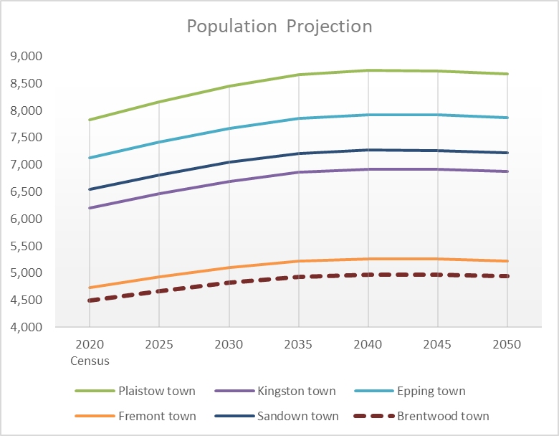
Brentwood’s population in 2020 (the last decennial census) was 4,490. The average age of residents (42.1) was less than the average for the RPC region (47) and slightly less than the state overall (44.9).
Demographics (RHNA) | Brentwood | RPC Region | State of NH
Total Population (2020) | 4,490 | 198,870 | 1,377,529
Average Age (2020) | 42.1 | 47 | 44.9
Population Over 65 (2020) | 795 | 53,873 | 245,142
Population Under 18 (2020) | 1,174 | 36,043 | 257,731
# Minors per Household | 0.76 | 0.45 | 256,876
School Enrollment (2021) | 657 | 22,753 | 163,688
Average Household Size - Renter (2020) | 2.22 | 2.09 | 2.26
Average Household Size - Owner (2020) | 2.64 | 2.6 | 2.5
Household # Family (2020) | 1,294 | 53,287 | 351,445
Household # Non-Family (2020) | 247 | 27,410 | 187,671
Persons with Disabilities | 301 | 21,295 | 170,907

Housing Units
Brentwood has an estimated 1,631 housing units, about 8% of which are renter-occupied, with the vast majority being owner-occupied. Regionally, more than 20% of housing is renter-occupied, and statewide nearly 25% is renter-occupied.
Housing Data (RHNA) | Brentwood | RPC Region | State of NH
# Housing Units | 1,631 | 88,586 | 638,611
Renter Occupied Units | 138 | 18,577 | 155,277
Owner Occupied Units | 1,403 | 62,120 | 383,839
Seasonal Housing Units | 24 | 4,487 | 70,149
Short-Term Rental Units | 0 | 845 | -
Occupied Housing | 1,455 | 82,268 | 556,375
Vacant Housing | - | 7,376 | 82,438

Affordability
Brentwood’s median household income is more than double than the statewide figure. The median home price in Brentwood is also considerably more than statewide
Affordability (RHNA) | Brentwood | RPC Region | State of NH
# Individuals Living Below Poverty Level | 47 | 9518 | 97,418
change since 2015 | -339 | -746 | -16,422
# Families with children below poverty level | 0 | 1806 | 11,298
change since 2015 | -52 | -427 | -3,664
change since 2010 | -13 | 206 | -2101
Median Household Income | $143,538 | $107,144 | $70,851
change since 2015 | $42,148 | $21,124 | $10,202
change since 2010 | $31,038 | $26,092 | $13,859
Median Home Sale Price (Zillow.com) | $639,123 | $527,000 | $403,000
change since 2015 | $264,123- | $192,000 | $158,073
change since 2010 | - | $272,000 | $218,500
Gross Rent by #Bedrooms - ALL (2022) | - | $1,595 | $1,790
change since 2017 | - | $238 | $348
change since 2012 | - | $481 | $529
FMR 3-bed (2023) | $2,034 | $2,168 | $2,290
income burden > 30% (2020) | 28.3% | 42.4% | 41.2%
income burden > 30% (2015) | 53.0% | 41.5% | 42.9%
income burden > 30% (2010) | 37.7% | 44.6% | 45.5%
NHHFA Median Purchase Price (2021) | $550,000 | $466,000 | $350,000
change since 2016 | $169,000 | $155,800 | $120,000
change since 2011 | - | $196,067 | $143,000
NHHFA Number of Sales (2021) | 57 | 2993 | 20,014
change since 2016 | 5 | -599 | -2,850
change since 2011 | 8 | 1416 | 10,171
HUD Estimated Maximum Affordable Purchase Price - 80% (2023) | $325,500 | $326,166.67 | $309,142.86
change since 2021 | -$13,000 | -$36,500.00 | -$30,714.28
change since 2019 | $73,500 | $50,166.67 | $41,642.86
HUD Estimated Maximum Affordable Purchase Price - 100% (2023) | $407,000 | $407,833.34 | $386,500
change since 2021 | -$16,000 | -$45,500.00 | -$38,214.29
change since 2019 | $94,500 | $59,666.67 | $55,714.29
HUD Estimated Maximum Affordable Monthly Rent - 60% (2023) | $1,840 | $1,820 | $1,747.14
change since 2021 | $400 | $323.33 | $311.43
change since 2019 | $570 | $426.66 | $395.71
Ownership HUD Median Area Income for Family of 4 - 80% (2023) | $108,800 | $107,706.67 | $103,474.29
change since 2021 | $23,520 | $18,960.00 | $18,365.72
change since 2019 | $33,360 | $25,120.00 | $23,428.58
Ownership HUD Median Area Income for Family of 4 - 100% (2023) | $136,000 | $134,633.34 | $129,342.86
change since 2021 | $29,400 | $23,700.00 | $22,957.15
change since 2019 | $41,700 | $31,400.00 | $29,285.72
Renter HUD Median Area Income Adjusted Family of 3 - 60% (2023) | $1,840 | $72,700 | $69,845.71
change since 2021 | $400 | $12,796.66 | $12,398.57
change since 2019 | $570 | $16,956.66 | $15,815.71

New Hampshire Statewide Housing Needs Assessment
Under RSA 36:47(II), each regional planning commission must compile a regional housing needs assessment (RHNA), including an assessment of the regional need for housing for persons and families of all levels of income. The regional housing needs assessment must be updated every 5 years and made available to all municipalities in the planning region. The 2023 assessment was completed in collaboration with the nine NH Regional Planning Commissions through a statewide effort, initiated by the Council on Housing Stability 2021-2024 Strategic Plan created under Governor Sununu.
The overall purpose of the RHNA is to provide current, regional, and local data and trends on housing and to identify future housing needs and opportunities. The assessment provides a foundation for communities to begin addressing housing barriers and opportunities. The 2023 RHNA also provides data on housing and demographics, by income level, so that each municipality in the region can begin to understand their current and future needs. In addition, the RHNA may assist municipalities in determining compliance with the Workforce Housing Statute (RSA 674:58-61).

Housing “Fair Share”
A large component of the RHNA is a Fair Share Table, which takes population projections and local housing trends to suggest what the future housing needs could be. Estimates for Brentwood are provided in the table below.
Projections By Year | 2025 | 2030 | 2035 | 2040
Total Units Needed (cumulative) | 108 | 198 | 260 | 294
“Affordable” Units Needed | 26 | 47 | 62 | 70
Market Rate Units Needed | 82 | 151 | 197 | 224
Rental Units V. Owned Units | 31.1% rental units needed; 68.9% owned units needed

Key RHNA Findings (Statewide)
- Based on estimated population growth, almost 60,000 units are needed between 2020 and 2030; nearly 90,000 units are needed between 2020 and 2040.
- From 2019 to 2022, the median home price in NH rose by 50%. As a result, middle to high income renter households are less likely to become homeowners.
- The state’s extremely low vacancy rate favors higher-income renters, as demand pushes rents beyond affordability levels for others, especially lower-income renters.
- Rent and home price increases outpaced wage growth. Between 2000 and 2020, New Hampshire’s home sales prices rose 111% and rents increased 94%, while household median income increased only 73%.
- Population growth will continue to slow through 2040, and NH’s population will become older, with fewer children per household. The desire to “age in place” will continue to limit the supply of homes available to purchase.

NH Workforce Housing Law
In 2008, the New Hampshire Legislature passed a law that requires every community to provide “reasonable and realistic opportunities” for the development of workforce housing. New Hampshire’s workforce housing statute (NH RSA 674: 58-61). The statute defines “workforce housing” and what is considered “affordable.”
New Hampshire is not a “home rule” state, which means all municipal power derives from a Legislative grant. RSA 672:1, III-e states that housing that is affordable to low- and moderate-income house­holds “shall not be prohibited or discouraged by use of municipal planning and zoning powers or by unreasonable interpretation of such powers.” The NH Supreme Court ruled in Britton v. Town of Chester, 134 N.H. 434 (1991), that municipalities are obliged to provide such households with a reasonable and realistic opportunity to obtain affordable housing, and that a municipality’s zoning cannot be used to prevent “outsiders of any disadvantaged social or economic group” from moving there.
Brentwood is within the Portsmouth-Rochester, NH HUD Metropolitan Fair Market Rent Areas (HMFA), which dictates the ownership prices and rent prices at which Brentwood should offer. These prices allow residents that make the Area Median Income (AMI) to be able to live in the community without great financial hardship. A workforce housing ordinance was removed by Town Vote in Brentwood. With the rising prices of homes, Brentwood may want to consider looking into re-establishing a workforce housing ordinance.
Per RSA 674: 58 – 61 the recommended maximum purchase price for workforce housing is $407,000 for those households making $136,000 and the maximum gross rent is $1,840 for households making $73,440.

Key considerations and implications for housing

Environmental Considerations

Rivers
Protecting river shorelines helps preserve wetlands, reduces flooding damage, serves to maintain important wildlife travel corridors, and preserves the scenic beauty and recreation value of the river. The town has a local shoreland and riparian buffer protection district that regulates building activities within a 300-foot buffer of its five rivers and streams. Although land use activities are controlled within the buffer the ordinance has a more restrictive element that prohibits the construction of buildings and septic systems within 150 feet of any regulated rivers and streams. The Exeter River, which leads into the Great Bay, is a resource that needs to be protected. Future development should be respectful of the town’s water resources, which could add additional cost and limit the project location.

Drinking Water
Brentwood residents rely on private wells fed by a large aquifer. Stormwater management and erosion control is a priority for Brentwood to protect the aquifer and preserve the health and safety of wells and their users. When stormwater goes unchecked, it can result in degradation of the quality of public and private wells.
The Town has significant groundwater resources in the eastern half of Town as mapped by the United States Geologic Survey. Although the Town has consistently determined that the construction of a municipal water system is not economically feasible the resource is significant enough to support such a system in the future if financial circumstance change. Recent years have seen local resources impacted by drought conditions. Even during sustained droughts developers have been able to site individual drinking wells on all sites approved for construction. The Town’s Aquifer Protection District regulates the land uses that may and may not occur over the aquifer resource and also requires additional study of the aquifer when substantial development projects are proposed within the protection district.
At the state level the NH Department of Environmental Services issues permits to anyone wishing to pump more than 67,000 gallons of water from a single well or series of closely located wells per day. These permits are granted only after pump tests prove that the aquifer resource will not be detrimentally impacted by the proposed groundwater removal.

Floodplains
Brentwood has a Floodplain Ordinance that protects the areas that are most susceptible to flooding activity. The Flood Plain District includes all special flood hazard areas designated as Zone A, A1-30 on the Brentwood Flood Insurance Rate Maps (FIRM), and the Flood Boundary and Floodway Maps. Adoption of this floodplain protection ordinance is required by the federal government for all communities that want to participate in the National Flood Insurance Program. This ordinance is an overlay district that prohibits substantial alterations without a certified engineer demonstrating that any proposed work shall not result in any increase in flood levels during the occurrence of the 100-year flood.

Wetlands
Brentwood has a wetlands ordinance that helps to protect the local wetlands against encroachment and ensuing degradation. The ordinance is unique in that the required protective buffer to a wetland resource is predicated upon the number of functions the wetland performs. If a wetland resource provides only flood water retention the buffer can be as small as 35 feet. When a wetland is providing flood retention, nutrient reduction, wild life habitat and any of the other nine functions that a wetland might provide, the buffer may be increased to as high as 100 feet. It is uncommon in New Hampshire for a local ordinance to protect wetlands in such a manner. Wetland functional valuation reports are required for all residential subdivisions and non-residential site plan review applications that are approved by the Planning Board.

Land Conservation
Land conservation is incredibly important for numerous reasons. By permanently protecting land from development natural resources and wildlife environments are secured, the rural character of the area can be enhanced, and drinking water supplies can be protected.
In Brentwood, the Conservation Commission holds conservation easements in order to protect land from development and degradation. Approximately 18% of the Town has been conserved through such easements and other conservation restrictions. Residents approved a $3M bond in 2022 to begin securing more land and/or easements.
There is however a cost to such land conservation policies. Taking developable land off the market and permanently removing its potential to be used for any development purposes drives up the cost of all remaining developable land in town. One of the areas of development most impacted is housing. Since the cost of land is the single highest factor in the end cost for constructed housing Land conservation negatively impacts the ability to provide new housing.

ECONOMIC DEVELOPMENT

Employment
Within Brentwood there are a few larger employers, including the Rockingham County Correctional Facility, the Rockingham County Courthouse, and the Brentwood Rehabilitation and Healthcare Center. These large locations each have more than 100 employees from Brentwood and the surrounding area. According to the US Census, out of all the people that are employed within Brentwood, 73.6% work in the region, and 23% have worked remotely from their Brentwood homes. Having a mix of local jobs as well as remote workers benefits the local economy and increases demand on housing stock. It is the responsibility of each community in NH to provide its residents with a mix of housing opportunity to help provide balance between jobs offered in an area and the housing necessary for those holding the jobs. Presently Brentwood does a poor job of providing a mix of residential housing types by heavily leaning toward high-cost low-density single-family housing.

INFRASTRUCTURE

Water and Sewer
As noted above, much like its neighboring communities, Brentwood relies on property owners to supply themselves with water via wells. This is an additional barrier to new development. Previously there were conversations with the Town of Epping about extending the water service along the NH Route 125 corridor. The Epping water system is located just to the North of the Brentwood border. This could serve the multifamily/professional office zone that has lacked housing development since its creation, however the system reportedly is likely insufficient to provide all of Brentwood with water and would be costly. Larger developments can create shared community well systems.
Just as with municipal water, Brentwood has no municipal sewer. This lack of infrastructure requires developers to think creatively to develop an efficient system. As with community wells, wastewater infrastructure can be shared. For example, the County Complex, which includes the nursing home, has a small wastewater treatment facility. With current wastewater technologies, parcel size is determined by soil type and the minimums that have been designated by the Brentwood Planning Board. Currently, within the multifamily district, each unit is required to have 2 acres of land. That requirement directly affects land availability and cost to the developer and the tenant.
The Town’s Economic Development Committee has explored grant opportunities to determine the feasibility of developing infrastructure along Route 125.

Transportation Network
Brentwood is well connected by major routes such as state roads 125, 111-A, 101 and 27. This road network allows residents to have jobs in other local communities and commute with ease. They can then return to their more rural setting. There is no public transportation, so residents of Brentwood are reliant upon their personal or family vehicles to get around. There is a Park and Ride location on I25 just north of the Brentwood border, which is a resource for people to carpool to locations. The Downeaster Amtrak line with service to Portland, ME and Boston, MA, stops in nearby Exeter. The town lacks pedestrian and bike infrastructure.
According to the American Community Survey 2017-2021 70.9% of workers over the age of 16 drive alone, 23.1% work from home, and 4.2% carpool. The average commute time to work for Brentwood residents is 31 minutes.

Energy Infrastructure
Brentwood is serviced by Unitil, Eversource and the New Hampshire Electric Co-Op. Having three providers in one community increases the town's resilience regarding emergency situations that cause outages. The Brentwood Energy & Efficiency Advisory Committee was established in Fall 2022 and has been tasked with researching electric policy, current services, and how they affect Brentwood. The Committee established a community power plan, which the Select Board adopted and voters approved, but it has not yet been implemented.

Historic Properties
Brentwood’s history is similar to other communities within Rockingham County. Settlers chose Brentwood, originally part of Exeter, for its relationship to the Exeter River. The river provided much-needed natural resources and eventually allowed residents to build mills and harness the river’s power for production. Housing development was focused around these mills and could mainly be found at Crawley Falls at the intersection of Old Route 125 and Middle Road (Route IIIA). The presence of wetlands, large swathes of agricultural uses, and slow transportation speeds caused the Town development to be spread out and it remains that way today.
Some of these historic remnants can still be seen today in the form of old farmhouses. 228 properties in Brentwood were built before the 1970’s, making them over 50 years old, which is considered a historic property. That is 14% of the current housing stock.
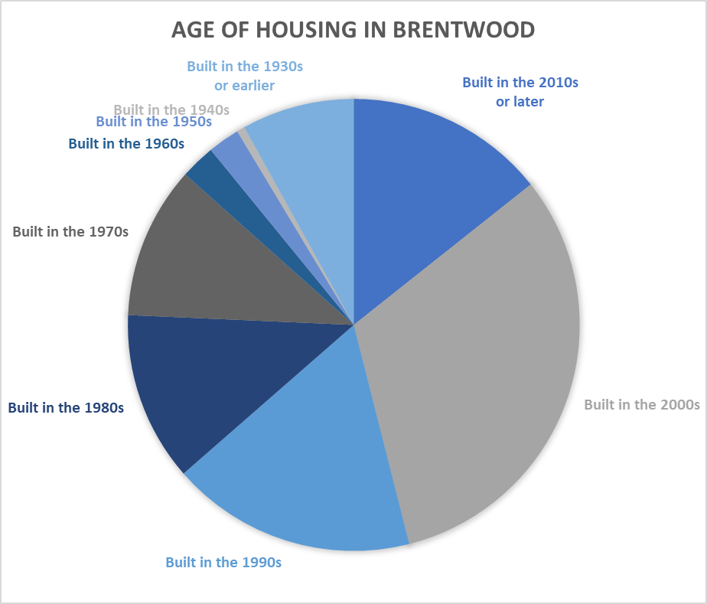
The largest percentage increase in housing construction in Brentwood occurred in the decade from 2000--2009 when 468 new houses were built. This accounted for 28% of the entire housing stock in Town. The decades on both sides of the highwater mark were both very busy as well. From 1990 – 1999 235 homes were built accounting for 14% of the total stock and from 2010 – 2019 an additional 297 homes accounting for 18% of the total housing stock were constructed. Most importantly this pie chart revels that since its incorporation in 1741 a little more than 60% of the housing in Brentwood has been constructed in the last thirty-five years.

Regulatory Challenges and opportunities for Housijng in Brentwood

For quite some time the Brentwood Planning Board has been concerned with the single-family monolith that describes housing opportunity in the Town. A series of ordinances have been adopted by voters and subsequently repealed by the voters that have had significant impacts on how housing is provided in Town. These challenges and possible opportunities for addressing these challenges are offered below.

Soil Type Lot sizing
For approximately ten years the Planning Board moved away from the requirement that each new house lot in town needed two acres of land; adopting a system where the minimum size for a new house lot was determined by the capacity of the soil to handle septic system effluent. Soil based lot sizing created one acre lots under new standards that had to be met by all such ordinances so the Town made some minor adjyus2015 the State of NH mandated the best conditions in Town. This increased density allowed for better use of the land in several development projects throughout town. Basing density on scientific factors instead of arbitrary lot size is also far easier to defend in any court proceeding. The Town could consider re-adopting soil type lot sizing and achieve greater density for housing while remaining environmentally sensitive.

Workforce Housing
The inability to create workforce housing in Town has been described earlier in this chapter. The State requirement that all communities must make provision for the creation of workforce housing is not going to be eliminated. Until the town re-adopts a workforce housing ordinance that complies with the state mandate and that is acceptable to the voters, Brentwood is in awkward position. A developer could propose a workforce housing project and in the absence of a local ordinance could sue the Town. Such a court proceeding can result is the developer being given a builder’s remedy. Such actions when granted, allow the construction of housing projects with no oversight by the Town. To avoid this worst-case scenario the Town needs to develop and adopt a workforce housing ordinance.

Multi-Family Housing
The Town adopted a multi-family zoning ordinance in 1991. Evidence of its ineffectiveness is that only one development has been constructed using it. A town the size of Brentwood that has no effective way of creating apartment style housing is unacceptable. The town needs to reevaluate the goals of the existing ordinance as well as the district’s location. The NH 125 and NH 27 corridors are perfect locations for multi-family apartment structures. Re-writing the existing code is not an easy endeavor. Time and care are required to draft an ordinance that could contain elements of mixed use, higher density and more flexible site plan design elements. The degree of effort required should not prohibit the good that could come to the community by way of greater housing opportunity.

Accessory Dwelling Units / Tiny Houses.

The only manner in which new rental construction has occurred in Brentwood is by way of Accessory Dwelling Units (ADU). These are apartments created within existing residential structures of either one or two bedrooms in size. The ability to create these units has been inn our zoning ordinance for decades. In 2015, the State of NH made such units mandatory for all communities and this resulted in the necessity to make minor changes to our local ordinance. Although not considered to be appropriate in the past, the Town may wish to consider widening the rules for ADU’s to allow for their placement outside of an existing residential home. Referred to as detached ADU’s these units may be constructed in barns and carriage houses or as standalone structures. Making this shift in the ordinance will require creating standards that will protect the visual single-family nature of Brentwood’s residential agricultural zoning district.
The Planning Board has been asked in the recent past to consider whether the construction of tiny houses could be a practical response to the Statewide housing shortage. The concept behind tiny houses is abandoning the concept that a home needs to be 2,000 square feet or larger and instead choosing to live homes of less than 800 square feet on average. This dramatically reduces the cost of the dwelling unit. The challenge for the Town becomes determining if these structures can be located on lots smaller than the required two acres. A tiny house costing $30,000 to construct immediately becomes less economically viable if it is required to be placed on a site of land that costs $200,000. The Town would need to consider allowing developments with smaller lot sizes to maintain affordability.

Municipal Housing Authority
Many larger communities in NH been very proactive in addressing housing affordability. One way to do this is to have a municipality create housing for its residents. Housing authorities raise tax dollars for the purchase of land and the construction of rental units (duplexes, triplexes and multi-family structures) that may then be rented to residents at less than market rate rentals. The Town of Brentwood may choose to investigate this opportunity in the future.

Housing Goals and Actions
Based on data provided here, the community housing survey, community engagement, and an audit of existing ordinances, the following goals and action items were drafted:
Goal 1 - Review and Monitor Housing Regulations
Actions
- Review the findings of the Brentwood Land Use Regulatory Audit to prioritize potential regulatory tools to increase housing diversity while meeting other Brentwood goals of maintaining rural character and fiscal responsibility.
- Continue to monitor the Town's housing stock on an annual basis through building permits issued and applications filed with land use boards.
- Continue to engage and educate Brentwood residents on the impact of potential housing related regulations. This should include engaging a variety of town entities and groups - such as the library - to help facilitate educational opportunities. A variety of engagement techniques should be used, and may include conducting tours of varies housing types in Brentwood or neighboring communities.

Goal 2 - Increase Housing While Retaining Rural Character
Actions
- Consider expanding the Accessory Dwelling ordinance to include detached dwellings that resemble garages and barns typically found in Brentwood or allowing Accessory Dwellings within existing detached structures.
- Consider studying the current Cluster Development ordinance to ensure it is protecting land while allowing housing production
- Investigate allowing more diverse housing types, which might include further development of ordinances that allow for tiny home construction, duplexes, mixed use, and multi-family housing. Additionally, explore the feasibility of creating a municipally owned housing project.
Goal 3 - Ensure Compliance with Workforce Housing RSA 674:58-61
Actions
- Consider adopting a Workforce Housing ordinance, using the ordinance that was repealed in 2010 as a starting place.
- Continue to monitor the Town's compliance with the Workforce Housing RSA.
- Continue to consider regulations to ensure fair and equitable housing opportunities without endangering Brentwood's resources.
- Continue to engage and educate Brentwood residents on the definition of workforce housing.

