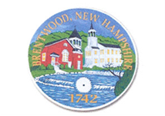

Town of Brentwood, NH
Town of Brentwood, NH Notice of Public Hearing
The Brentwood Select Board will hold a Public Hearing at 6:00 PM on Tuesday, February 25, 2025, at the Brentwood Town Hall Meeting Room relating to a petition warrant article.
The public is invited to provide comments and input to the Board.
This public hearing is conducted under the provisions of NH RSA 32:5-c (Adoption of Local Tax Cap).
Signed:
The Brentwood Select Board

