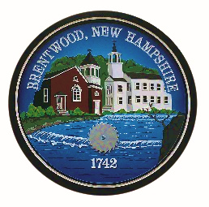
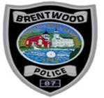
BRENTWOOD POLICE DEPARTMENT
1 DALTON RD.
BRENTWOOD, NH 03833
Tel: (603) 642-8817 Fax: (603) 642-3165
E-mail: info@brentwoodpd.com

Chet Murch
Chief of Police

PROPERTY CHECK REQUEST FORM
Owner Name: ________________________________________________________________________
Address: ____________________________________________________________________________
Property Description (Business, Residence, Etc.): ____________________________________________
Date of Departure: ________________________________
Date of Return: ___________________________________
Alarm: __________________________________________
Name of Alarm Company: _____________________________________________________________
Address: ___________________________________________________________________________
Telephone #: _____________________________________
Will there be vehicles left on your property? If yes, please describe: ____________________________
Will there be animals left on your property? If yes, please describe: ____________________________
Will anyone be checking your property or working there? If yes, please provide their name and contact information: ________________________________________________________________________
Have you left keys to your property with anyone else? If yes, please provide their name and contact information: ________________________________________________________________________
Emergency contact: ___________________________________________________________________
Please provide us means of contacting you in case of emergency: ______________________________
Please help us by double checking your property to make sure it is secure before you leave. Check all doors and windows to your house, vehicles, and any other structures on your property.
Thank You,
The Brentwood Police Department

