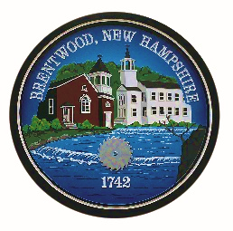
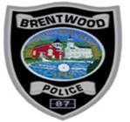
BRENTWOOD POLICE DEPARTMENT
1 DALTON RD.
BRENTWOOD, NH 03833
Tel: (603) 642-8817 Fax: (603) 642-3165
E-mail: info@brentwoodpd.com

Chet Murch
Chief of Police

Property Return Request Form

Property other than bicycles can only be returned by the Property Room Officer. The Brentwood Police Department utilizes one Property Room Officer; due to this there may be a delay in receiving your property.
If you are seeking the return of a firearm or other type of weapon seized as part of an arrest or restraining order, you must first file a “Motion to Return” with the court. Weapons will not be returned without a motion from the court granting the return.
All other property that may be returned pursuant to state law will be returned as soon as possible. Please complete the form below, which will expedite the return of said property.

PLEASE PRINT OR TYPE

Type of Property: ___________________________________________________________
_____________________________________________________
Type of Incident: ___________________________________________________________
Name of Owner of Property: __________________________________________________
Address of Owner: __________________________________________________________
__________________________________________________________

Telephone Number of Owner: ____________________________
Date of Birth of Owner: _________________________________
Social Security of Owner: ________________________________

Signature of Owner: ____________________________________ Date: ________________
Signature of Officer:____________________________________ Date: ________________

